Ex.No.13: V2X Latency Comparison
AIM: To simulate and compare the performance of a Vehicle-to-Everything (V2X) communication system by analyzing End-to-End Latency (ms), Packet Delivery Ratio (%), and Vehicle Speed (km/h) using MATLAB.
Objective – 1: To evaluate the End-to-End Latency (ms) of a V2X communication system under different vehicle operating conditions.
Program:
clc;
clear;
close all;
% Vehicle Speed (km/h)
speed = 20:20:120;
% Simulated End-to-End Latency (ms)
latency = [18 16 14 12 10 9];
disp('Vehicle Speed (km/h) End-to-End Latency (ms)')
disp([speed' latency'])

figure
% -------- Graph 1 --------
subplot(2,1,1)
plot(speed,latency,'-o','LineWidth',2)
title('Vehicle Speed vs End-to-End Latency')
xlabel('Vehicle Speed (km/h)')
ylabel('Latency (ms)')
grid on
% -------- Graph 2 --------
subplot(2,1,2)
plot(1:length(latency),latency,'-s','LineWidth',2)
title('Latency Variation Across Vehicles')
xlabel('Vehicle Index')
ylabel('End-to-End Latency (ms)')
grid on clc;
clear;
close all;
% Vehicle Speed (km/h)
speed = 20:20:120;
% Simulated End-to-End Latency (ms)
latency = [18 16 14 12 10 9];
disp('Vehicle Speed (km/h) End-to-End Latency (ms)')
disp([speed' latency'])

figure
% -------- Graph 1 --------
subplot(2,1,1)
plot(speed,latency,'-o','LineWidth',2)
title('Vehicle Speed vs End-to-End Latency')
xlabel('Vehicle Speed (km/h)')
ylabel('Latency (ms)')
grid on
% -------- Graph 2 --------
subplot(2,1,2)
plot(1:length(latency),latency,'-s','LineWidth',2)
title('Latency Variation Across Vehicles')
xlabel('Vehicle Index')
ylabel('End-to-End Latency (ms)')
grid on
OUTPUT 1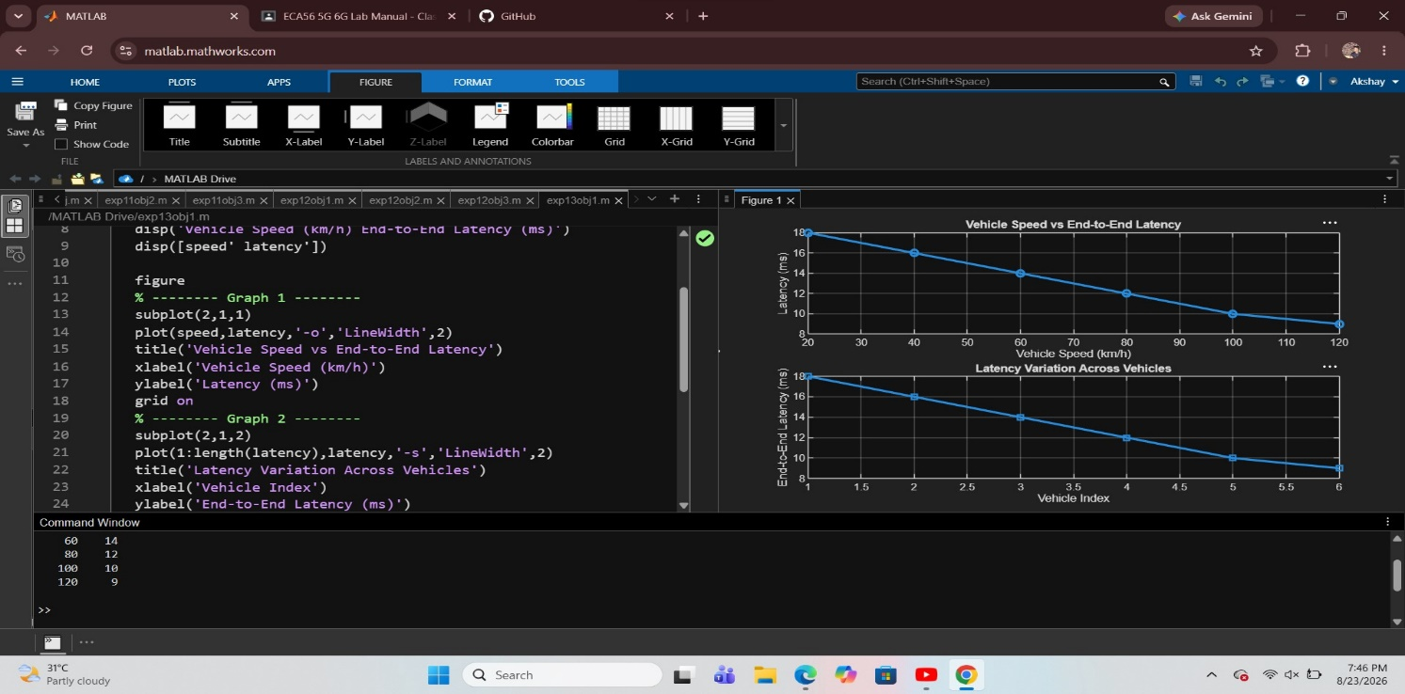Objective 2: To analyze the Packet Delivery Ratio (%) and determine the reliability of V2X communication during data transmission.

Program:
clc;
clear;
close all;
% Vehicle Speed (km/h)

speed = 20:20:120;
% Simulated Packet Delivery Ratio (%)
PDR = [99 98 97 95 93 90];
disp('Vehicle Speed (km/h) Packet Delivery Ratio (%)')
disp([speed' PDR'])
figure
% -------- Graph 1 --------
subplot(2,1,1)
plot(speed,PDR,'-o','LineWidth',2)
title('Vehicle Speed vs Packet Delivery Ratio')
xlabel('Vehicle Speed (km/h)')
ylabel('Packet Delivery Ratio (%)')
grid on
% -------- Graph 2 --------
subplot(2,1,2)
plot(1:length(PDR),PDR,'-s','LineWidth',2)
title('Packet Delivery Ratio Across Vehicles')
xlabel('Vehicle Index')
ylabel('Packet Delivery Ratio (%)')
grid on clc;
clear;
close all;
% Vehicle Speed (km/h)

speed = 20:20:120;
% Simulated Packet Delivery Ratio (%)
PDR = [99 98 97 95 93 90];
disp('Vehicle Speed (km/h) Packet Delivery Ratio (%)')
disp([speed' PDR'])
figure
% -------- Graph 1 --------
subplot(2,1,1)
plot(speed,PDR,'-o','LineWidth',2)
title('Vehicle Speed vs Packet Delivery Ratio')
xlabel('Vehicle Speed (km/h)')
ylabel('Packet Delivery Ratio (%)')
grid on
% -------- Graph 2 --------
subplot(2,1,2)
plot(1:length(PDR),PDR,'-s','LineWidth',2)
title('Packet Delivery Ratio Across Vehicles')
xlabel('Vehicle Index')
ylabel('Packet Delivery Ratio (%)')
grid on
Output 2:
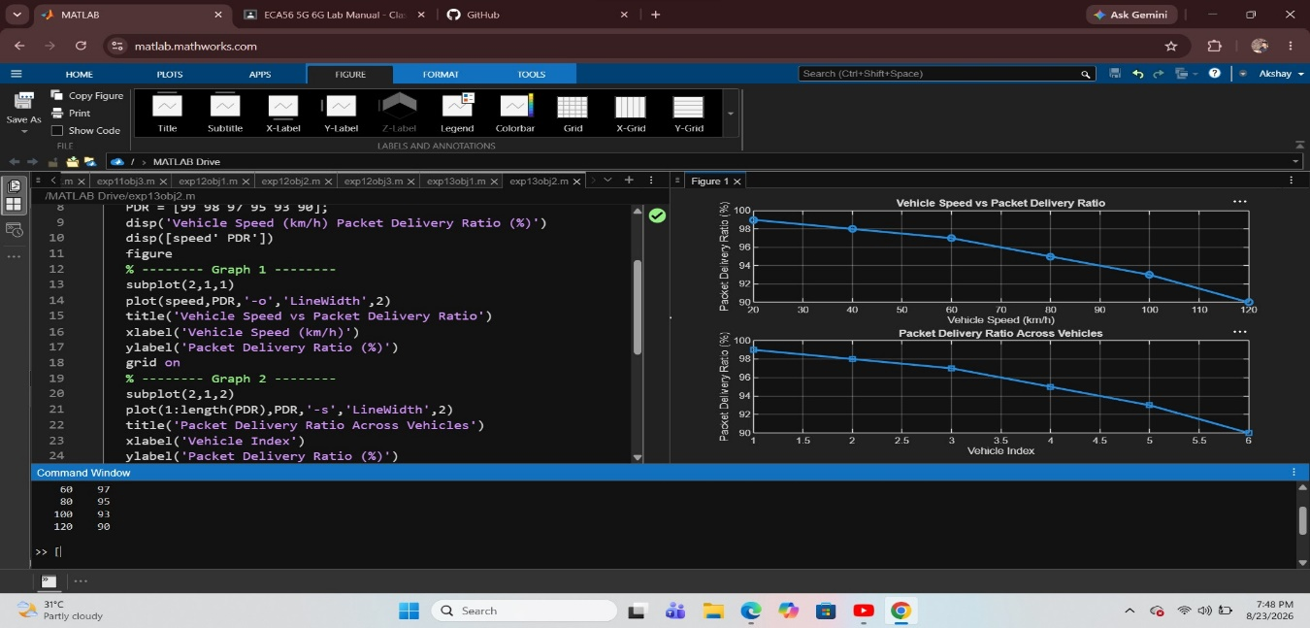
Objective 3: To study the impact of Vehicle Speed (km/h) on the communication performance and stability of the V2X network. To study the impact of Vehicle Speed (km/h) on the communication performance and stability of the V2X network.
Program:
clc;
clear;
close all;
% Vehicle IDs
vehicle = 1:6;
% Vehicle Speed (km/h)
speed = [30 45 60 75 90 105];
% Communication Range (m)
range = [280 260 240 220 200 180];
disp('Vehicle Speed(km/h) Communication Range(m)')
disp([vehicle' speed' range'])
figure
% -------- Graph 1 --------
subplot(2,1,1)
plot(vehicle,speed,'-o','LineWidth',2)
title('Vehicle Speed of Different Vehicles')
xlabel('Vehicle Index')
ylabel('Vehicle Speed (km/h)')
grid on
% -------- Graph 2 --------
subplot(2,1,2)
plot(speed,range,'-s','LineWidth',2)
title('Vehicle Speed vs Communication Range')
xlabel('Vehicle Speed (km/h)')
ylabel('Communication Range (m)')
grid on clc;
clear;
close all;
% Vehicle IDs
vehicle = 1:6;
% Vehicle Speed (km/h)
speed = [30 45 60 75 90 105];
% Communication Range (m)
range = [280 260 240 220 200 180];
disp('Vehicle Speed(km/h) Communication Range(m)')
disp([vehicle' speed' range'])
figure
% -------- Graph 1 --------
subplot(2,1,1)
plot(vehicle,speed,'-o','LineWidth',2)
title('Vehicle Speed of Different Vehicles')
xlabel('Vehicle Index')
ylabel('Vehicle Speed (km/h)')
grid on
% -------- Graph 2 --------
subplot(2,1,2)
plot(speed,range,'-s','LineWidth',2)
title('Vehicle Speed vs Communication Range')
xlabel('Vehicle Speed (km/h)')
ylabel('Communication Range (m)')
grid on
OUTPUT 3:
